**Requirement Gathering and Analysis Phase**

**Data Flow Diagram & User Stories**

|  |  |
| --- | --- |
| Date | 06 Jul 2024 |
| Team ID | SWTID1721040922 |
| Project Name | WalletWatch (Personal Expense Tracker) |
| Maximum Marks |  |

**Data Flow Diagrams:**

A Data Flow Diagram (DFD) is a traditional visual representation of the information flows within a system. A neat and clear DFD can depict the right amount of the system requirement graphically. It shows how data enters and leaves the system, what changes the information, and where data is stored.

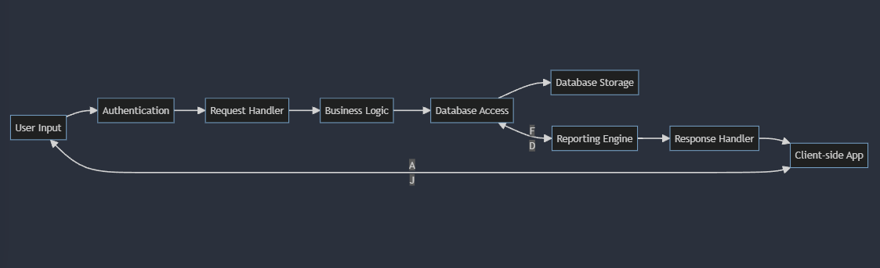

**User Stories**

Use the below template to list all the user stories for the product.

| **User Type** | **Functional Requirement (Epic)** | **User Story Number** | **User Story / Task** | **Acceptance criteria** | **Priority** | **Release** |
| --- | --- | --- | --- | --- | --- | --- |
| Customer (Mobile user) | Registration | USN-1 | As a user, I can register for the application by entering my email, password, and confirming my password. | I can access my account / dashboard | High | Sprint-1 |
|  |  | USN-2 | As a user, I will receive confirmation email once I have registered for the application | I can receive confirmation email & click confirm | High | Sprint-1 |
|  | Login | USN-3 | As a user, I can log into the application by entering email & password |  | High | Sprint-1 |
|  | Dashboard |  | As a mobile user, I can view a summarized overview of my current balance, total income, and total expenses on my dashboard. |  |  |  |
| Customer (Web user) | Registration | USN -1 | As a web user, I can register for the application by entering my email, password, and confirming my password. | I can access my account / dashboard | High |  |
|  |  | USN-2 | As a user, I will receive confirmation email once I have registered for the application | I can receive confirmation email & click confirm |  |  |
|  | Login | USN-3 | As a user, I can log into the application by entering email & password |  | High |  |
|  | Dashboard |  | As a web user, I can see an overview of my financial status, including current balance, income, and expenses on my dashboard. |  |  |  |
| Customer Care Executive |  |  |  |  |  |  |
|  |  | USN-1 | As a customer care executive, I can search for users by email or username. |  | HIGH |  |
|  |  | USN-2 | As a customer care executive, I can assist users with account-related issues such as password resets and account recovery. |  | MEDIUM |  |
| Administrator |  | USN-1 | As an administrator, I can manage user roles and permissions within the application. |  | HIGH |  |
| Administrator |  | USN-2 | As an administrator, I can configure system settings such as currency formats and language preferences. |  | MEDIUM |  |
|  |  | USN-2 | As an administrator, I can view aggregate statistics and analytics of user transactions and financial activities. |  | HIGH |  |
|  |  |  |  |  |  |  |